SIMATS ENGINEERING (SAVEETHA SCHOOL OF ENGINEERING)

Department of Computer Science and Engineering

ASSESSMENT TOOL 2 – Industry Problem Solving Task

Course Code: | CSA07 | Course Title: | Computer Networks
CO Assessed: | CO4 – K2 - Imitation | Assessment: | Assessment Tool 2 – Industry Problem Solving Task
Weightage: | 25% of CIA | Slot | A
CO Statement: | Design network topologies star, mesh, bus, and hybrid using networking devices, transmission media, and cabling standards (BL2, BL6)
Student Name: | P.V. GIRIDHAR | Reg. No.: | 1972260022
Section / Batch: | B.TECH CSE AI | Date:
Code of Conduct
I P.V. GIRIDHAR (1972260022) (Name / Reg No) certify that this submission is my original work and that I have adhered to the
guidelines specified for this assessment. I understand that any violation of academic integrity rules will result in disciplinary action.
Signature of the Student: Kamalesh.s
Instructions
- Duration: 45 minutes. Off-Class Assessment
- Complete the task using only digital tools such as Excel, Google Sheets, Python/Google Colab, or Power BI.
- Use the assigned dataset and follow the hints given in the question.
- Perform basic data analysis and include at least 2 relevant visualizations.
- Clearly present your observations, identified industry problem, supporting evidence, and recommended solution.
- Prepare the final findings in PDF/DOCX/Excel/Colab Notebook format.
- Create a dedicated folder in the given GitHub repository and upload all required files.
- Submit the GitHub folder link along with the final findings in Google Classroom (GCR).
- Ensure that both the GitHub link and uploaded files are accessible before final submission.
- Late submissions will be subject to mark penalties. Ensure that the GitHub files are accessible and the GCR submission is completed before the deadline.

Section / Topic | Focus | Q.  No.
10. Transport Layer Fundamentals | TCP and UDP traffic characteristics; packet behaviour; comparison of TCP-based Video Streaming and UDP-based VoIP | Q2
11. Congestion Control & Quality of Service | Network congestion, latency, traffic load, QoS analysis, and network performance improvement | Q1
12. Queuing Models & Modern Protocols | Queue length, communication delay, congestion states, and network traffic behaviour | Q3

Rubrics for Calculation

Criteria | Weightage | Level 4 – Exemplary | Level 3 – Proficient | Level 2 – Developing | Level 1 – Beginning
Understanding of Industry  Problem | 20% | Comprehensive understanding of real-world  problem and constraints | Good  understanding with minor gaps in  requirements | Basic  understanding; some  requirements unclear | Poor  understanding; misinterprets problem  context
Application of Engineering Concepts | 25% | Applies advanced and relevant concepts  effectively to solve the problem | Applies  appropriate concepts with minor errors | Limited  application of concepts | Incorrect or no application of concepts
Solution Design | 25% | Innovative, practical, and  feasible solution aligned with industry  standards | Logical and feasible  solution with minor gaps | Basic solution with limited feasibility | Unclear or impractical solution
Use of Tools | 15% | Effective use of modern tools,  technologies, and real data | Appropriate use of tools with correct  implementatio n | Limited or inconsistent use of tools | Minimal or incorrect use  of tools
Analysis | 10% | Thorough analysis with validated results and  performance evaluation | Good analysis with  reasonable validation | Basic analysis with limited validation | Poor or no analysis
Professionalism | 5% | Highly  professional, well-documented,  and clearly  presented work | Good  documentation and  presentation | Basic  documentation with some gaps | Poor  documentation and  presentation

Q. No.  / Criteri a | Understan ding of Industry Problem | Application of Engineering Concepts | Solution Design | Use of Tools | Analysis | Sub. Total | Total  %
1
2
3

Faculty In-charge | Course Coordinator | Program Director

Signature: | Signature: | Signature:

Annex: 3. Industry Problem Solving Task

- Network Quality Dataset
https://www.kaggle.com/datasets/yehezkielhaganta/network-quality-dataset/data

Industry Scenario: An organization notices that its network becomes slow when network traffic increases. Using the Network Quality Dataset, investigate whether high traffic is associated with increased latency. Hint: First identify the traffic_in_bps, traffic_out_bps, and latency_ms columns. Group or observe the data during different traffic conditions, create a line chart or scatter plot, and compare traffic levels with latency. Identify periods where latency becomes noticeably high and suggest one simple network improvement based on your observation. Use only digital tools such as Excel, Google Sheets, Python/Google Colab, or Power BI.

- Network Traffic Dataset – Video Streaming vs VoIP
https://www.kaggle.com/datasets/sxham04/network-traffic-dataset/data

Industry Scenario: A company uses the network for both video meetings and voice calls. Network engineers want to understand how these two applications behave differently. Using the Network Traffic Dataset, compare Video Streaming TCP and VoIP UDP traffic. Hint: Use Activity_Type, Protocol, and Packet Length to separate and compare the two traffic types. Calculate simple statistics such as average packet length, create a bar chart or box plot, and identify which traffic type has different communication characteristics. Based on your observation, suggest which type of traffic should receive higher priority during network congestion and explain why. Use only digital tools.

- VANET Traffic Congestion Dataset
https://www.kaggle.com/datasets/ucimachinelearning/vanet-traffic-congestion-dataset/data

Industry Scenario: A smart-transportation company wants to know how road congestion affects communication between connected vehicles. Using the VANET Traffic Congestion Dataset, investigate how Free-flow, Moderate, Heavy, and Gridlock conditions affect network communication. Hint: Compare packet_loss_pct, communication delay, queue length, and channel busy ratio across the four congestion states. Start by calculating the average value for each congestion state, then create suitable bar charts or line charts. Identify the congestion state where communication performance becomes significantly worse and recommend one practical network-level action to improve communication reliability. Use only digital tools.

Question 1 – Congestion Control & Quality of Service
Industry Scenario: An organization notices that its network becomes slow when network traffic increases. Using the Network Quality Dataset, this analysis investigates whether high traffic is associated with increased latency.

Dataset and Method
The Network Quality Dataset contains 59,946 timestamped observations recorded from 09 June 2026 16:48 to 10 June 2026 23:59, with four fields: timestamp, traffic_in_bps, traffic_out_bps, and latency_ms. For this analysis, traffic_in_bps and traffic_out_bps were summed into a single total_traffic figure (converted to Mbps) for each observation, and this was compared directly against latency_ms.

Three checks were performed:
  - Pearson correlation between total traffic and latency across all 59,946 records.
  - Grouping traffic into four equal-sized levels (Low, Medium, High, Very High, via quartiles) and comparing mean/median latency in each group.
  - Comparing average traffic during the top 10% highest-latency periods against the overall average traffic.

Observations

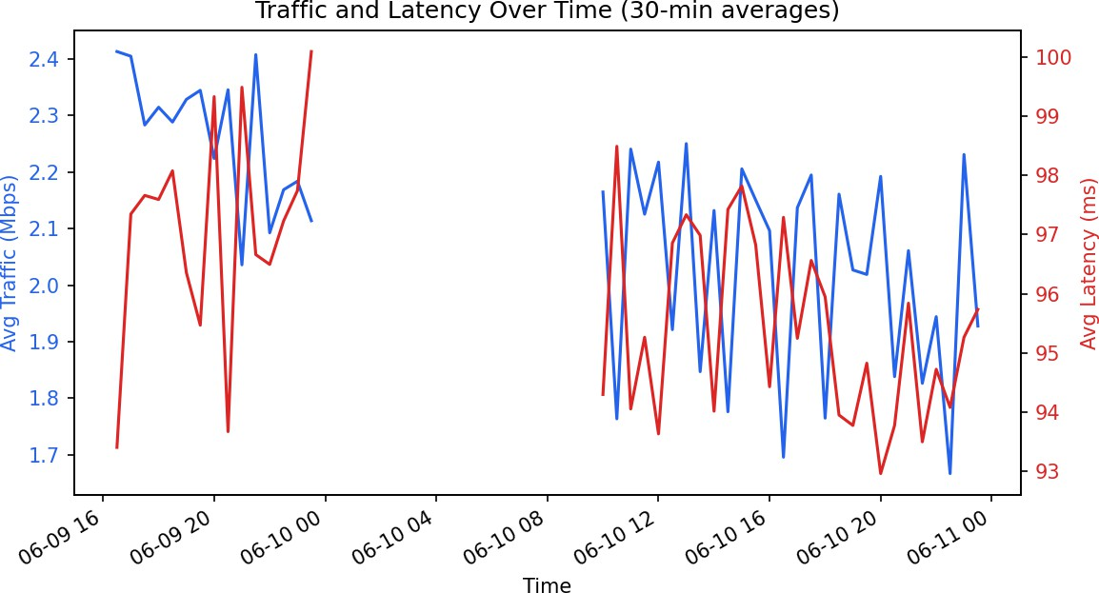

Figure 2: 30-minute average traffic and latency over the recording period.
Key figures from the analysis:
  - Correlation between total traffic and latency: r ≈ −0.017 (essentially zero — no meaningful linear relationship). A fitted trend line has a slope of about −1.1 ms per extra Mbps of traffic — flat, and in the opposite direction to what the industry scenario assumed.
  - Mean latency by traffic level — Low: 98.98 ms, Medium: 93.51 ms, High: 95.94 ms, Very High: 95.55 ms. The differences between the busiest and quietest quarters of the network are within a few milliseconds.
  - Overall latency ranges from 14.6 ms to 684 ms, with a mean of ~96 ms and a 90th-percentile of 143 ms.
  - During the highest-latency periods (top 10%), average total traffic was 2.16 Mbps, essentially the same as the overall average of 2.09 Mbps.

Interpretation
The data does not support the assumption that rising traffic volume is the direct cause of the slowdowns users are noticing. Latency stays in a similar band (roughly 90–100 ms on average) whether the link is carrying very little traffic or the most traffic recorded. The occasional very high latency spikes (up to 684 ms) occur at both low and high traffic levels, which points to an intermittent or external cause — such as an upstream ISP/route issue, Wi-Fi interference, DNS resolution delay, or server-side response time — rather than the organisation's own link being saturated by volume.

Recommended Improvement
Because the bottleneck does not correlate with local traffic volume, the most useful next step is not simply adding bandwidth. It is recommended that the organisation deploy continuous network path monitoring (e.g., traceroute/MTR sampling alongside the existing latency logging) to isolate exactly which hop or segment is responsible for the latency spikes, and to configure Quality-of-Service (QoS) traffic prioritisation for latency-sensitive applications (e.g., video calls, VoIP) so that even if traffic later becomes the cause, real-time traffic is shielded from queuing delay.

Question 2 – Transport Layer Fundamentals
Industry Scenario: A company uses the network for both video meetings and voice calls. Network engineers want to understand how these two applications behave differently. This analysis compares Video Streaming (TCP-based) and VoIP (UDP-based) traffic using the Network Traffic Dataset.

Dataset and Method
The Network Traffic Dataset contains 89,709 captured packets with fields Time, Protocol, Length, and Activity_Type. Packets were grouped by Activity_Type and Protocol: Video_Streaming traffic runs almost entirely over TCP/TLSv1.3 (77,725 packets), and VoIP_Call traffic runs almost entirely over UDP (11,984 packets, including STUN/RTCP control packets).
Average packet length, packet rate, and estimated throughput were calculated for each traffic type.

Observations

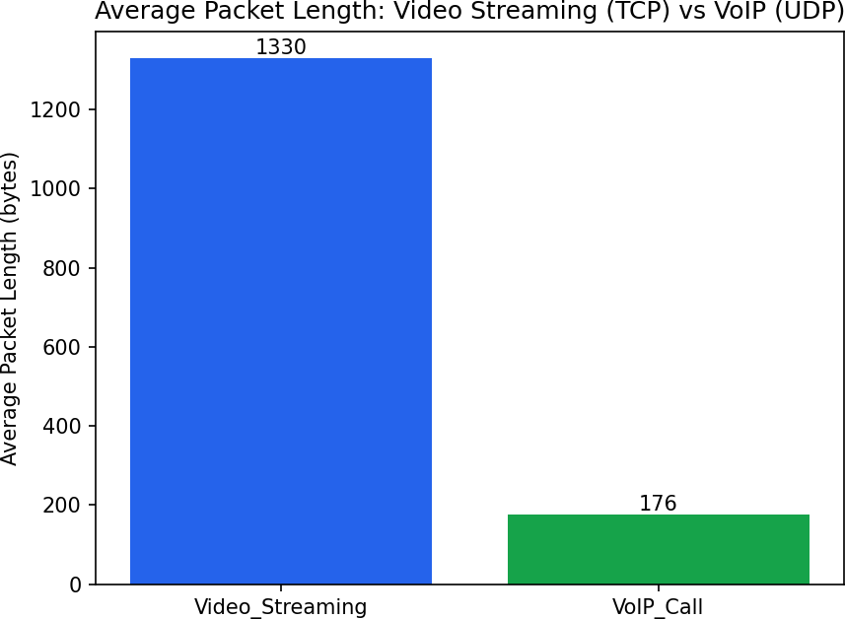

Figure 3: Average packet length by traffic type.

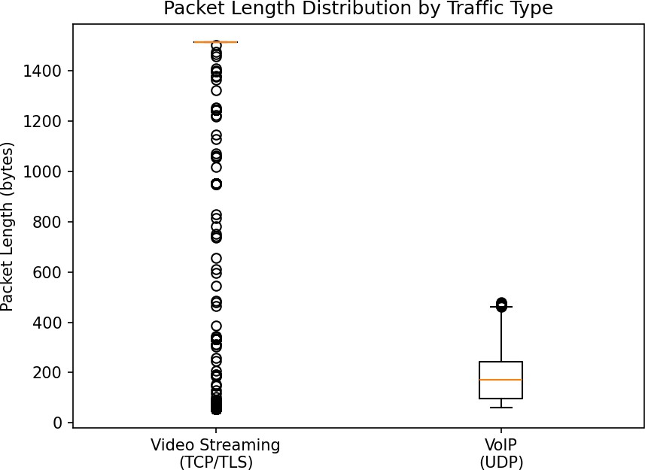

Figure 4: Distribution (spread) of packet length by traffic type.
Key figures from the analysis:
  - Average packet length — Video Streaming: 1,330 bytes (median 1,514 bytes, close to the Ethernet MTU); VoIP: 176 bytes (median 172 bytes).
  - Packet rate — Video Streaming: ~120 packets/second; VoIP: ~19 packets/second.
  - Estimated throughput — Video Streaming: ~1.28 Mbps average; VoIP: ~27 kbps average.
  - Video Streaming packets are large and bursty, clustering at the maximum segment size (1,514 bytes), consistent with bulk, buffered TCP data transfer. VoIP packets are small, frequent, and evenly spaced, consistent with a steady
real-time UDP audio stream.

Interpretation
The two traffic types have fundamentally different characteristics. Video Streaming (TCP) prioritises reliability and throughput: it uses large packets and retransmission/acknowledgement to guarantee every byte arrives, which is acceptable because a media player can buffer a few seconds of video. VoIP (UDP) prioritises timeliness over reliability: it sends small, frequent packets with no retransmission, because a delayed audio packet is more disruptive than an occasionally dropped one.

Recommendation
During network congestion, VoIP traffic should receive higher priority than Video Streaming traffic. VoIP is far more sensitive to delay and jitter — a queuing delay of even 150 ms is audible as a stutter or echo in a phone call, whereas the same delay is invisible to a viewer because Video Streaming already relies on client-side buffering to smooth out variations. In practice this means configuring QoS/DSCP marking (e.g., EF – Expedited Forwarding for VoIP/RTP, AF for video) so that routers and switches place VoIP's small UDP packets ahead of TCP video traffic in the queue during periods of congestion.

Question 3 – Queuing Models & Modern Protocols
Industry Scenario: A smart-transportation company wants to know how road congestion affects communication between connected vehicles (VANET), across Free-flow, Moderate, Heavy, and Gridlock conditions.
Note: The VANET Traffic Congestion Dataset referenced for this question was not included among the uploaded files (only the Network Quality Dataset and the Network Traffic/VoIP dataset were provided, used in Questions 1 and 2 above). The dataset would need to be supplied to compute the required per-state averages of packet_loss_pct, communication delay, queue length, and channel busy ratio and to generate the bar/line charts this question asks for.

Expected approach once the dataset is available
  - Group records by congestion state (Free-flow, Moderate, Heavy, Gridlock).
  - Calculate the mean packet_loss_pct, communication delay, queue length, and channel busy ratio for each state.
  - Plot these as bar charts (one per metric, states on the x-axis) or line charts if the states are treated as an ordered progression.
  - Identify which state shows the sharpest degradation (typically expected to be Gridlock, where vehicle density is highest and channel contention is greatest) and recommend a network-level action such as adaptive beaconing rate control or multi-channel operation to reduce channel congestion.

